Telusko: Core Java 02

011 DOUBT
Today discussion is QA(doubts resolving) not live session
Doubt discussion : wednesday( 2PM to 4PM IST)
saturday (6PM IST to 8PM IST)
next live class on : Monday(7.30PM IST to 10.30PM IST)
email id : nitin@ineuron.ai
syedhaider@ineuron.ai
----------------------------------------------------------------------------
Q>
what is jar files?
Collection of .class files we represent as Jar files(Java Archieve file).
Q>
which editor I used for java program and how to use eclipse for java program
editor -> Editplus /notepad
IDE -> using Eclipse,later we move to STS(Spring tool Suite)
Q>what is the difference between method and main method?
main method -> it is a method from where the jvm would start the
execution.
method -> set of instructions written by programmer.
Q> yesterday snippet 4 private cls and arguments
private class Demo{
public static void main(String[] args){
System.out.println(args[1]);
}
}
should be under public)
java Demo Good morning guys
javac Demo.java //Compile time Error(file name which contains main()
Q> please tell me the concept of (String [] agrs)
It will discussed when we talk on "Arrays" ,followed by "String"
class.
The data will be stored inside the args in the form of String and
it is an Array.
Q>byte ab=10; // data compiler by default treats as int,but in the range of byte so
no problem
byte ac=2; // data compiler by default treats as int,but in the range of byte so no
problem
byte result = ab*ac;// when we perfom the operation compiler is designed to store
the data in the higher
datatype of the specific type
eg: byte(1),short(2),int(4)
int result = byte * byte
----->type promoted to int
System.out.println(result);
Q> sir whatis differenc in git master and main .yesterday I was uploading a file on
GitHub and
it was not uploading with git push -u origin main .bit it worked with git
push -u master?
ans. branch names they are, it will taught moving further.
Q> sir in one interview , interviewer asked me what is the diff b/w a=a+1 and a++?
byte a = 10;
a = a + 1;//CE:possible loss of precession
System.out.println(a);stored
byte a = 10;//JVM will give memory of 1 byte and data 10 is
a++;//no problem for compiler
// a = (byte)(a+1);//11 will be stored as a byte by the JVM
System.out.println(a);
byte a = 10;
discussed,no problem for compiler
a+=1;//Short hand operator in operators topic it will
and jvm will resolve it through explicit
typecasting.
System.out.println(a);
Q> sir what will happen if we add multiple main methods ?
a. can we write mulitple methods with same name in a single class
class Test
{
public static void main(String[] args)
{
System.out.println("hiee");
}
{
public static void main(String[] args)
System.out.println("hello");
}
}
output: CompileTime Error
Q> Sir why the 'S' in system and ' S' in string is in upper case letter. can you
explain it?
reserved words -> It should start with lower case(convention followed
by Oracle team)
ClassName/interface name -> It should start with Upper case.(convention
followed by Oracle team).
int,float,double -> reserve words so lower case
String,System -> class name so upper case
Q> sir can we write class without main method means like empty class?
Ans. yes, possible but that file can't be given to jvm (java FileName).
If we give it would result in "Exception" as main method not
found.
Q> what if variable name and reserve keywords got same in same program?
int int a = 10; //CE: becoz reserve words can't be used as a
identifier/varaible name
Q> sir if we use class name first letter in small case will it be a problem?
No problem ,but as a good practise follow the convention to avoid the
disturbance in readability
eg: class Test{}//code is as per Convention(experience developers code)
class test{}//code is not per Convention(inexperienced developers
code)
Q>
sir what is difference between top down and bottom up approach in progammingApproach towards solving the code in realtime.(DSA part it is)
Q>
Hi Nitin, byte is able to store 1 byte of memory but char can store 2 bytes
of memory so internal typecasting won't be happened. but why it haven't throw error
in byte code
byte b='a'; as right side value will be assigned to b.
byte ----> 1 byte
char ----> 2 byte
Compiler is desinged to this type of conversion so we call this as "Implicit type
casting".
float ---------> double
byte------------> short -------------> int -------------> long ----------->
^
|
|
char(2 bytes) ====> to
support "Internationalization"
Internationlization -> Supporting the application to the end users as per there
country regional language.
Reverse of it if has to be done then programmer should write the statement of
casting it is called as
"Explicit type casting".
Q> sir why always it is necessary to define the main method as 'static' ?
JVM should call main method without creating the Object.
if a method is marked as static then that method would be called using
ClassName
So we want jvm to call main method using className so mark main() as
"static

012 Operators , Conditionals , Switch case in Java

contact details
hyder : syedhaider@ineuron.ai
nitin : nitin@ineuron.ai
7.
Given code of Test.java file:
public class Test {
public static void main(String[] args){
args[1] = "Day!";
System.out.println(args[0] + " " + args[1]);
}
}
And the commands:
javac Test.java
java Test Good
What is the result?
A. Good
B. Good Day!
C. Compilation Error
D. JVM would create a problem during execution
answer : D
Consider below code of Test.java file:
public class Test {
public static void main(String[] args){
System.out.println("Welcome " + args[0] +"!");
}
}
And the commands:
javac Test.java
java Test "James Gosling" "Bill Joy"
What is the result?
A. Welcome James Gosling!
B. Welcome Bill Joy!
C. Welcome "James Gosling"!
D. Welcome "Bill Joy"!
E. Welcome James!
F. Welcome Gosling!
G. Welcome Bill!
H. Welcome Joy!
answer : A
10.
Consider below code of Test.java file:
public class Test {
public static void main(String[] args) {
boolean b1 = 0;
boolean b2 = 1;
System.out.println(b1 + b2);
}
}
A. 0
B. 1
C. true
D. false
E. compilation error
What is the result of compiling and executing Test class?answer : E
11.
Given:
35. String #name = "Jane Doe";
36. int $age = 24;
37. Double _height = 123.5;
38. double ~temp = 37.5;
Which two statements are true? (Choose two.)
A. Line 35 will not compile.
B. Line 36 will not compile.
C. Line 37 will not compile.
D. Line 38 will not compile.
answer : A,D
12.
What will be the result of compiling and executing Test class?
public class Test {
public static void main(String[] args){
byte b1 = ( byte ) ( 127 + 21 ); // byte b1 = (byte)(148)
System.out.println(b1);
}
}
A. 148
B. Compilation Error
C. -108
D. -128
JVM : minrange + (result-maxrange-1)
= -128 + (148 - 127-1)
= -128 +(148-128)
= -128 +(20)
= -108
13.
Consider below code of Test.java file:
public class Test {
public static void main(String[] args) {
char c1 = 'a'; //ASCII code of 'a' is 97
int i1 = c1; //Line n1 // char----> int (implicit typecasting)
System.out.println(i1); //Line n2
}
}
What is the result of compiling and executing Test class?
A. a
B. 97
C. Line n1 causes compilation failure
D. Line n2 causes runtime error.
answer : B
14.
Given code of Test.java file:
public class Test {
public static void main(String[] args) {
byte b1 = 10; //Line n1
int i1 = b1; //Line n2 Compiler : byte-----> int(Implicit typecasting)
byte b2 = i1; //Line n3 Compiler : int------> byte (hey not possible u
explicitly tell)
System.out.println(b1 + i1 + b2);
}}
What is the result of compiling and executing Test class?
A. Line n1 causes compilation error
B. Line n2 causes compilation error.
C. Line n3 causes compilation error.
D. 30 printed on to console.
answer : C
15.
For the given code what is the output?
int x=100;
int a=x++; // a = 100, x = 101
int b= ++x;// b = 102, x = 102
int c= x++;// c = 102, x = 103 true
true value
int d= (a<b) ? (a<c) ? a: (b<c)? b: c :x;//int d= (100<102)?(100<102):100
System.out.println(d);//100
A. 100
B. 101
C. 102
D. 103
E. compilation fails
answer: A
16.
class Test
{
{
public static void main(String[] args)
int a=100; // a= 10-
System.out.println(-a++);//System.out.println(-100); now a = 101
}
}
A. -101
B. 99
c. Compilation error
d. -100
e. -99
answer : d
fallthrough in switch
---------------------------
int a = 97;
switch(a){
case 97: System.out.println("hello");
case 98: System.out.println("hiee");
}
output: hello
hiee
since there is no break automatically control executed the next case also,this
condition in java under switch we call as
"fallthrough".
Sir Please You Can Explain For What We Use = a+""+b+""+c+""
int a= 10,b=20,c=30;
System.out.println(a + " " + b + " "+ c);//10 20 30javac Test.java
java Test ind.txt
java Test aus.txt
public class Test{
public static void main(String args[]){
//file name will be supplied from the command line arguments
//code written to open the file and read the contents from the file
}
}
ind.txt
rahul
rohith
kohli
aus.txt
warner
finch
smith

public class Launch1
{

public static void main(String[] args)
{
int a=4;
int b=2;
int res=a%b;
System.out.println(res);

}

}

public class Launch2 {

public static void main(String[] args) {
// TODO Auto-generated method stub

/*
* int a=10; int b=20;
*
* System.out.println(a>b); System.out.println(a<b); System.out.println(a==b);
*/
/*
* int abc=5; abc=10;
*
*
*
* int a,b,c,d;
*
* a=b=c=d=10+5;
*
* System.out.println(a + " "+b + " " +c+" "+d);
*/

int a=2;

a+=20;
System.out.println(a);
a-=20;
System.out.println(a);
a*=20;
System.out.println(a);
a/=20;
System.out.println(a);
a%=20;
System.out.println(a);

}

}

public class Launch3 {

public static void main(String[] args) {
// TODO Auto-generated method stub

/*
* int a=8; int b=2;
*
* if(a>b) { if(a==10) { System.out.println("Subtraction");
* System.out.println(a-b); } else {
* System.out.println("A is greater but not equal to 10"); } } else if(a==b) {
* System.out.println("Addition"); System.out.println(a+b); } else if(a<b) {
* System.out.println("a is lesser"); } else {
*
* }
*/

/*
* int a=10; int b=20; int c=5;
*
* if(a<b) { if(a<c) { System.out.println("A is the least "+a); }
*
* else { System.out.println("C is the least"+c); } } else if(b<c) {
* System.out.println("B is least" +b); } else {
* System.out.println("C is least"+ c);
*
* }
*/

int a=10;
int b=20;
int c=30;

if(a<b && a==b)
{
System.out.println("A is least");
}
else if(b<c && b==a)
{
System.out.println("B is least");
}
else if(c <a && c<b)
{
System.out.println("else block last block");
}
else
{
System.out.println("Last block");
}

}

}

public class Launch4 {

public static void main(String[] args) {
// TODO Auto-generated method stub
/*
* int a=10; int b=20;
*
*
* int c= (a<b)? a: b; System.out.println(c);
*/

int a=100;
int b=20;
int c=60;

int res = (a<b)? (a<c? a:c):(b<c?b:c) ;
System.out.println(res);

int num1=100;
int num2=20;
int num3=60;
if(num1<num2)
{
if(num1<num3)
{
System.out.println(num1);
}
else
{
System.out.println(num3);
}
}
else if(num2<num3)
{
System.out.println(num2);
}
else
{
System.out.println(num3);
}

}

}

public class Launch5 {

public static void main(String[] args) {
// TODO Auto-generated method stub

int number=100;

switch(number){

case 100: System.out.println("1st case");
break;
case 108: System.out.println("2nd case");
break;
case 10: System.out.println("3rd case");
break;

default : System.out.println("no cases matching");

}

}

}

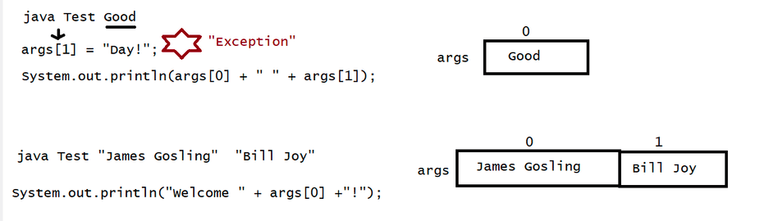
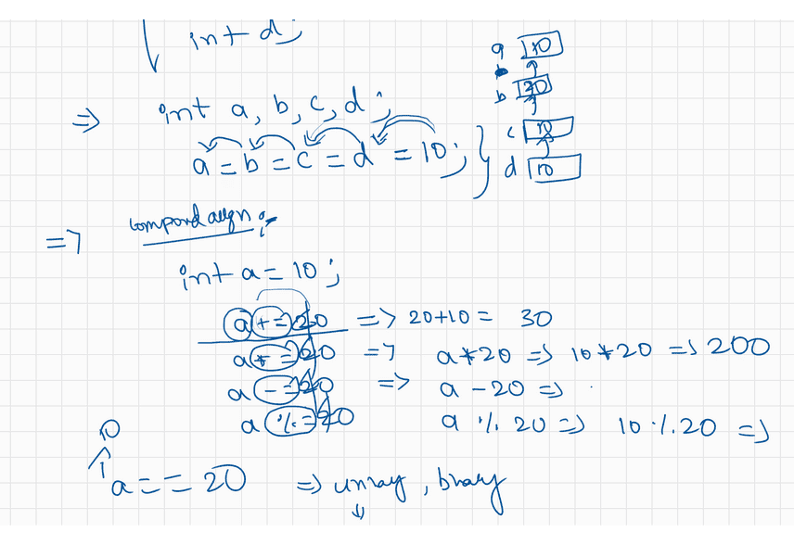
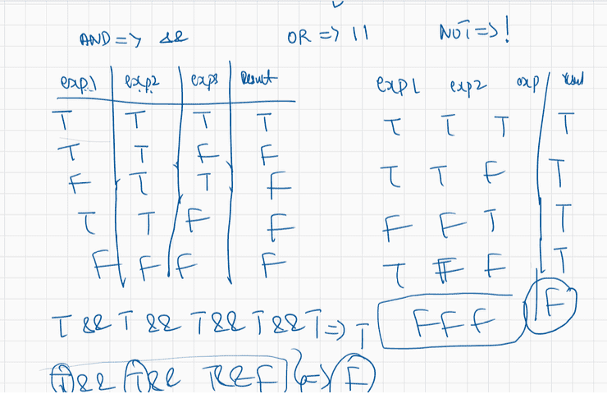
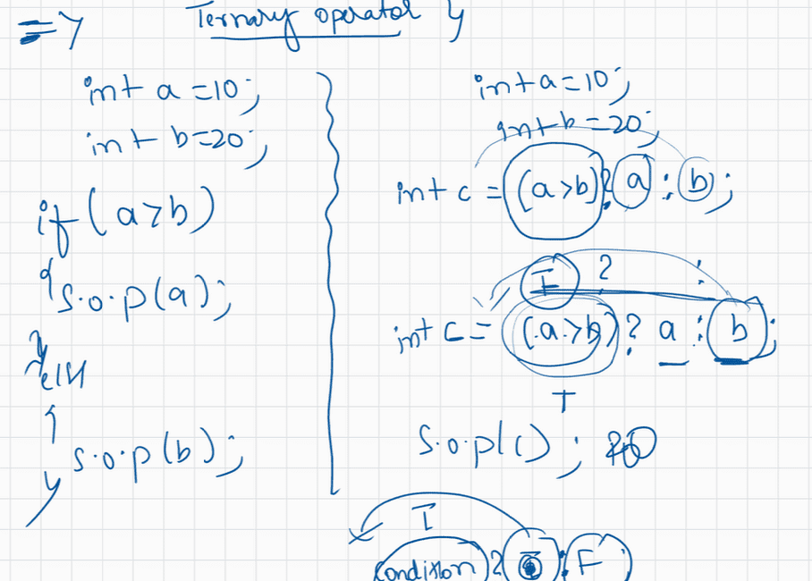
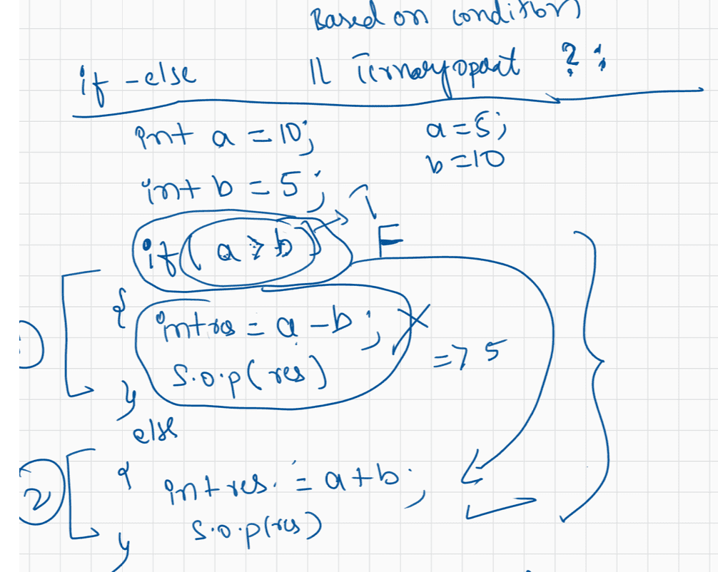

013 Loops and Pattern Programming

Q>
Consider below code:
public class Test {
public static void main(String[] args) {
char c = 'Z';
long l = 100_00l;//from JDK1.7 for a literal we can give _ also, if we give
compiler will remove that _ in .class file
int i = 9_2;//from JDK1.7 for a literal we can give _ also, if we give
compiler will remove that _ in .class file
float f = 2.02f;
double d = 10_0.35d;//from JDK1.7 for a literal we can give _ also, if we
give compiler will remove that _ in .class file
l = c + i;//char + int = int int -----> long (implicit)
f = c * l * i * f;//char * long*int*float = float
f = l + i + c;//long+int+char = long long---> float(implicit)
i = (int)d;//double----> int(explicit)
f = (long)d;//double---> long , long ---> float (implicit)
}
}
A. Yes
B. No
Answer : A
Does above code compile successfully?
Q>
{
class Test
{
public static void main(String[] args)
int a = 20; // a = 18
int var= --a * a++ + a-- - --a;// var = 19 * 19 + 20 -18 = 363
System.out.println("a = " + a);// a = 18
System.out.println("var = " + var);//var= 363
}
}
A.
B.
a = 18
var=363
a = 363
var=363
C. Compilation Error
D.
a = 25
var= 363
answer : A
Q>
{
class Test
{
public static void main(String[] args)
int i = 5; // i = 5,6,7
//5 < 6(true)
if (i++ < 6)
{System.out.println(i++);//System.out.println(6)
}
}
}
A. 5
B. 6
D. 7
C. Program executes succesfully but nothing is printed on to console
Q>
int x = 4;//line-n1
int y = 4++;//line-n2 variables not on direct literals
System.out.println(x);
System.out.println(y);
whether it is post or pre-increment it can only be done on
A. line-n1 CompileTimeError
B. x=4
y=5
C. x=5
y=5
D. line-n2 CompileTimeError
Answer: D
Q>
24
int x = 4;//line-n1
int y =++(++x);//line-n2 whether it is post or pre-increment it can only be done
on variables not on direct literals
System.out.println(x);
System.out.println(y);
A. line-n1 CompileTimeError
B. x=4
y=5
C. x=5
y=5
D. line-n2 CompileTimeError
Answer: D
Q>
boolean b=true;//line -n 1
b++;//line-n2 Ans. increment and decrement is applicable only for
integral,floating type and character type not for boolean type
System.out.println(b);
A. line-n1 Compile Time Error
B. line-n2 Compile Time Error
C. false
D. true
E. None of the above
Anser : B
Q>
int b,c,d;//declaring the variablesint a= b = c = d=10;/intializing the values for b=c=d and finally giving the
value to a variable with declaration
Will the code compile?
A. yes
B. no
Answer: A
Q>
int a = b = c = d = 20;//b,c,d not declared but using so CompileTime Error
System.out.println(a);
Will the code compile?
A. yes
B. no
Answer : B
Q>
byte c = (10> 20) ? 30 : 40;//literals are involved so compiler performs operation
byte c =40;
byte d =(10<20) ? 30 : 40;//literals are involved so compiler performs operation
byte d =30;
System.out.println(c);//40
System.out.println(d);//30
A. 30
40
B. 40
30
C. 10
20
D. 20
10
E. CompiletimeError
Answer : B
Q>
int a = 10, b = 20;//type checking is valid no problem
byte c = (a>b) ? 30 : 40;//literals are not involved in operation, so compiler
would just check type checking of result
Compiler will see 30,40 type it knows is int,
so the result should be of int type only.
if compiler only perform the operation it will
try to map with casting chart otherwise it wants
the exact type.
byte d =(a<b) ? 30 : 40;
System.out.println(c);
System.out.println(d);
A. 30
40B. 40
30
C. 10
20
D. 20
10
E. CompiletimeError
Answer: E
Q>
Consider below statements:
1. int x = 5____0;// Literal values can be with _ also but it should be in b/w not
at the beginging or at the end
2. int y = ____50;//invalid becoz starts with _
3. int z = 50____;//invalid becoz in ends with _
4. float f = 123.76_86f;//valid
5. double d = 1_2_3_4;//valid
How many statements are legal?
A. One statement only
B. Two statement only
C. Three statement only
D. Four statement only
E. All 5 statement only.
Answer : C
Note:
Compiler -> it checks only the syntax and makes the jvm execution smoothful
JVM -> Creates the memory for the variables and perform type casting and
generates the result.

public class Launch1
{

public static void main(String[] args)
{
int n=10;
for(int i=0; i<n;++i)
{
System.out.println("*");
}

}

}

public class Launch2 {

public static void main(String[] args) {
// TODO Auto-generated method stub

int n=5;
int i=0;
while(i<n)
{
System.out.print("*");
i++;
}

}

}

public class Launch3 {

public static void main(String[] args) {
// TODO Auto-generated method stub

int n=15;
for(int i=0;i<n;i++)
{
for(int j=0;j<n;j++)
{
System.out.print("*");
}
System.out.println();
}

}

}

public class Launch4 {

public static void main(String[] args) {
// TODO Auto-generated method stub

int n=10;
for(int i=0;i<n;i++)
{
for(int j=0;j<n;j++)
{

if((i==0 && j<n-1) || j==0 ||(i==n-1 && j<n-1)|| (j==n-1 &&i>0 &&i<n-1) )
{
System.out.print("*");
}
else
{
System.out.print(" ");
}

}
System.out.println();
}

}

}

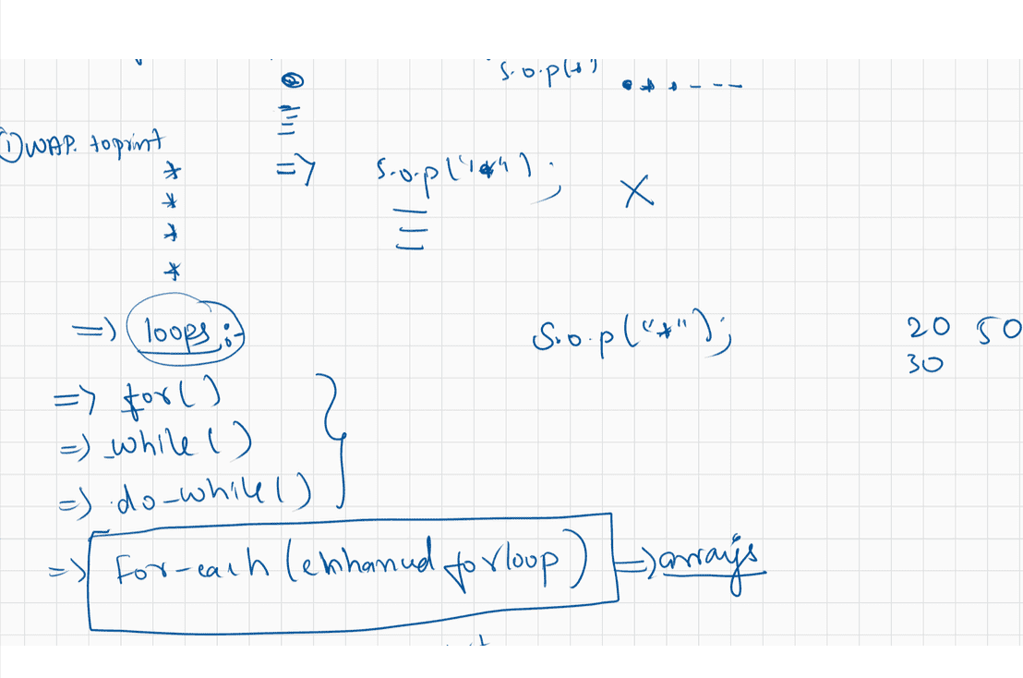
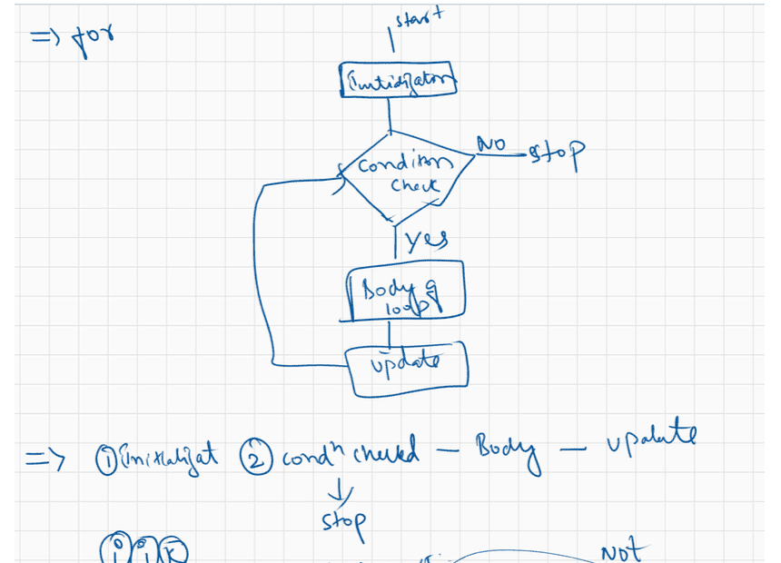
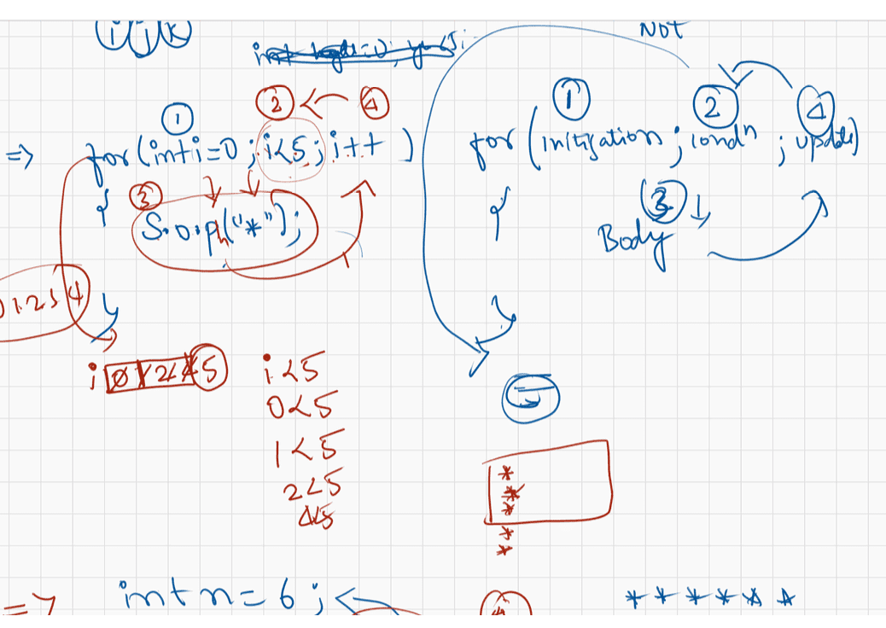
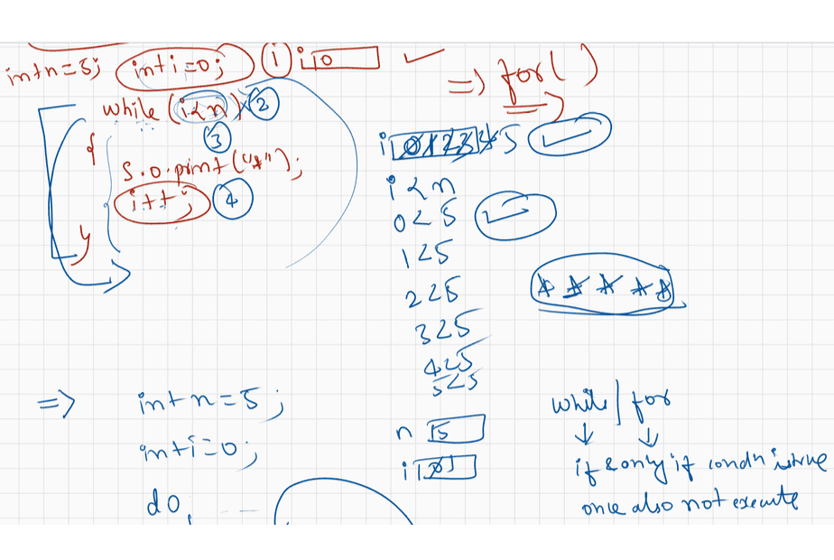
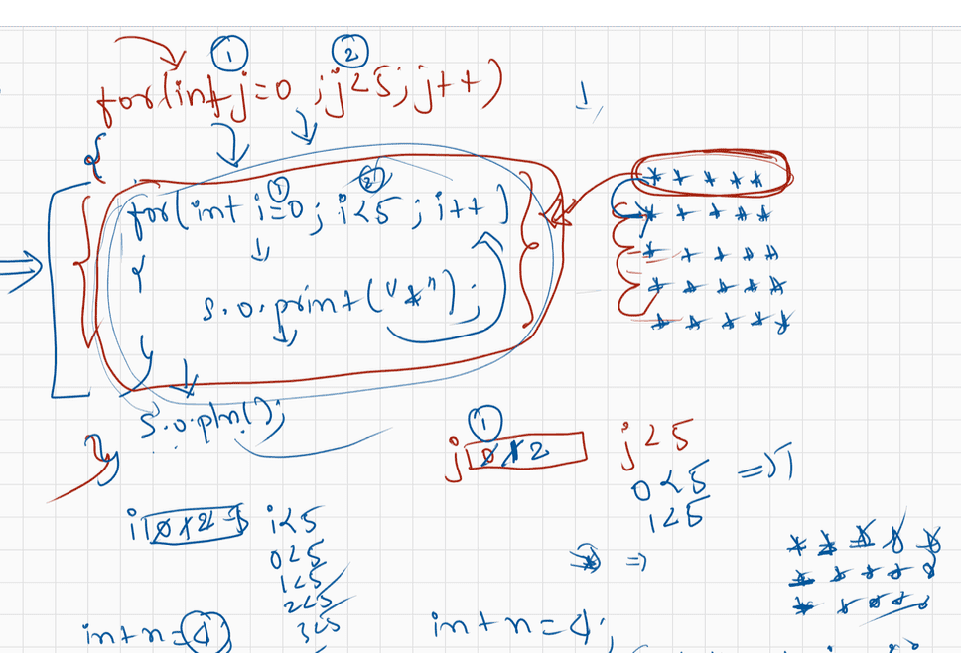
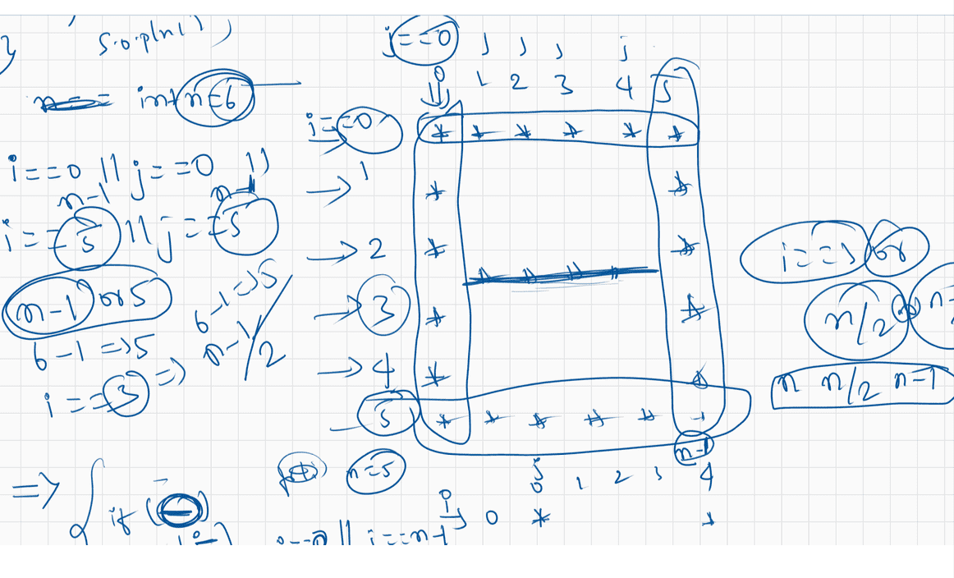

015 Pattern programming part 02
contact details
haider : syedhyder@ineuron.ai
nitin : nitin@ineuron.ai
Q>
int x=10 , y=15 ;
if(++x < 10 & ++y > 15) { x++;
//11<10(false) & 16>15(true)
}
else {
y++;//17
}
System.out.println(x+"----"+y);
predict x and y value by replacting the operators with
|| => x and y value ?
|| -> it is called as "Short circuit OR operator"
second operand evaluation will happen only if the first operand result
is false
x = 12
y = 16
&& => x and y value
&& -> it is called as "Short circuit AND operator"
second operand evaluation will happen only if the first operand result
is true
x = 11
y = 16
| => x and y value
|=> It is called as "Logical OR operator"
both the operands result will be evaluated.
x = 12
y = 16
& => x and y value ?
& -> It is called as "Logical AND operator"
both the operands result will be evaulated
x =11
y =17
Q>
int x=10 ;
if(++x < 10 && ((x/0)>10) ) { //11<10===> if(false)
System.out.println("Hello");
}
else {
System.out.println("Hi");
}
A. Hello
B. Hi
C. Compile Time Error
D. Exception
E. None of the above.
Answer : BQ>
Give
int i=10;//10
int j=20;//30
int k= (j+=i)/5;// k = (j= j+i)/5
k= (j=20+10)/5
k = (j=30)/5
k= 30/5
k= 6
System.out.println(i+":"+j+":"+k);
A.10:30:6
B.10:22:22
C.10:22:20
D.10:22:6
Answer : A
Q>
Syntax of if
--------------
if(boolean){
stmt-1;
stmt-2;
}else{
stmt-3;
stmt-4;
}
int x =10;
if(x){//CE: unexpected type required: boolean,found:int
System.out.println("hello");
}else{
System.out.println("hiee");
}
A. hello
B. hiee
C. CompileTime Error
D. Some problem by jvm at the execution
E. None of the above
Answer: C
Q>
int x =10;
if(x=20){//CE: unexpected type required: boolean,found:int
System.out.println("hello");
}else{
System.out.println("hiee");
}
A. hello
B. hiee
C. CompileTime Error
D. Some problem by jvm at the execution
E. None of the above
Answer: C
Q>int x =10;
if(x==20){//operator used is Equality operator System.out.println("hello");
==, != output is boolean
}else{
System.out.println("hiee");
}
A. hello
B. hiee
C. CompileTime Error
D. Some problem by jvm at the execution
E. None of the above
Anser: B
Q>
boolean b= false;
if(b=true){//assignment operator is evaluted on boolean data type, JVM if(true)
System.out.println("hello");
}else{
System.out.println("hiee");
}
A. hello
B. hiee
C. CompileTime Error
D. Some problem by jvm at the execution
E. None of the above
Answer : A
Q>
boolean b= false;
if(b==true){//Equality operator result is boolean type , JVM if(false == true) ----
> if(false)
System.out.println("hello");
}else{
System.out.println("hiee");
}
A. hello
B. hiee
C. CompileTime Error
D. Some problem by jvm at the execution
E. None of the above
Answer: B
Q>
if(boolean)
stmt-1;
optional.
if(true)
Note: if there is only statement which needs to be a part of if, then {} is
System.out.println("hello");
A. Compile Time Error
B. hello
C. Some problem by jvm at the execution
D. None of the above
Answer : BQ>
public class Test{
public static void main(String args[]){
if(true);
}
}
A. Compile Time Error
B. hello
C. Some problem by jvm at the execution
D. No Output
Answer : D(becoz ; is also valid java statement)
Q>
Note: if there is only statement which needs to be a part of if, then {} is
optional,but that statement should not
be a declarative statement.
public class Test{
public static void main(String args[]){
if(true)
int x=10; //CE: declaration not allowed here
}
}
A. Compile Time Error
B. hello
C. Some problem by jvm at the execution
D. No Output
Answer: A
Q>
public class Test{
public static void main(String args[]){
if(true) {
int x=10; //valid for compiler becoz of {}
}
}
}
A. Compile Time Error
B. hello
C. Some problem by jvm at the execution
D. No Output
Answer: D
Q>
public class Test{
public static void main(String args[]){
if(true)
System.out.println("hello");//Dependent of if statement
System.out.println("hiee");//Independent of if statement
}
}
How many statements are independent of if?
A. 0-stmt
B. 1-stmt
C. 2-stmtD. 3-stmt
Answer: B

public class Launch4 {

public static void main(String[] args) {
// TODO Auto-generated method stub

int n=10;
for(int i=0;i<n;i++)
{
for(int j=0;j<n;j++)
{
// G (i==0 && j>0 && j< (3*n)/4) ||
/*(j==0 && i>0 && i<n-1) ||
(i==(n-1)/2 && j>=(n-1)/2 && j<=(3*n)/4) ||
(j==(3*n)/4 && i>=(n-1)/2) ||
(i==n-1 && j<(n-1)/2) ||
(j==(n-1)/2 && i>=(n-1)/2)*/

//H j==0 || j==(3*n)/4 || i==(n-1)/2 && j<=(3*n)/4
if(j==0 || i==0 && j<(n-1)/2 || i==(n-1)/2 && j<(n-1)/2 ||
j==(n-1)/2 && i<(n-1)/2 && i>0)
{
System.out.print("*");
}
else
{
System.out.print(" ");
}

}
System.out.println();
}

}

}

public class Launch5 {

public static void main(String[] args) {
// TODO Auto-generated method stub

int n=10;

for(int i=0;i<n; i++)
{
for(int j=0 ; j<n; j++)
{
if((j==0 && i>0) ||
(i==(n-1)/2 && j<=(3*n)/4) ||
(i==0 && j<(3*n)/4) && j>0||
(j==(3*n)/4 && i>0))
{
System.out.print("*");
}
else
{
System.out.print(" ");

}

}
for(int j=0 ; j<n; j++)
{
if((i==0 && j<(n-1)/2)|| (i==(n-1)/2)&& j>0 && j<(n-1)/2
||(i==n-1 && j<(n-1)/2) ||
(j==(n-1)/2 && i>0 && i!=(n-1)/2 && i<n-1) || j==0
)
{
System.out.print("*");
}
else
{
System.out.print(" ");

}

}
for(int j=0 ; j<n; j++)
{
if(i==0 && j>0 && j<(3*n)/4 || j==0 && i>0 && i<n-1
|| i==n-1 && j>0 && j<(3*n)/4)
{
System.out.print("*");
}
else
{
System.out.print(" ");

}

}
System.out.println();
}

}

}

public class Launch6 {

public static void main(String[] args) {
// TODO Auto-generated method stub
int n=28;
for(int i=0;i<n;i++)
{
for(int j=0;j<n;j++)
{
if(i+j==(n-1)/2 || i-j==(n-1)/2 ||
j-i==(n-1)/2 ||i +j == n -1+ (n-1)/2||

i==j || i+j ==n-1
|| i==0 || j==0 || i==n-1 || j==n-1)
{
System.out.print("*");
}
else
{
System.out.print(" ");
}
}
System.out.println();
}
}

}

public class Launch8 {

public static void main(String[] args) {
// TODO Auto-generated method stub

int n=11;
for(int i=0;i<n;i++)
{
for(int j=0;j<n;j++)
{
if((i==n/4 && j>n/4 && j<(3*n)/4)||

(i==(3*n)/4) && j>n/4 && j<(3*n)/4 ||
(j==n/4 && i>n/4 && i<(3*n)/4) ||
(j==(3*n)/4) && i>n/4 && i<(3*n)/4||
(i==j) && i>n/2 && j>n/2)
{
System.out.print("*");
}
else
{
System.out.print(" ");
}
}
System.out.println();
}

}

}

public class Launch10 {

public static void main(String[] args) {
// TODO Auto-generated method stub

int n=11;
for(int i=0;i<n;i++)
{
for(int j=0;j<n;j++)
{
if( i+j>=(n-1)/2 && j<=(n-1)/2 && i<=(n-1)/2||
i-j<=(n-1)/2 && i>=(n-1)/2 && j<=(n-1)/2||
j-i <=(n-1)/2 && j>=(n-1)/2 && i<=(n-1)/2
|| i+j <= n-1 + (n-1)/2 && i>(n-1)/2 && j>(n-1)/2

)
{
System.out.print("*");
}
else
{
System.out.print(" ");
}
}
System.out.println();
}

}

}

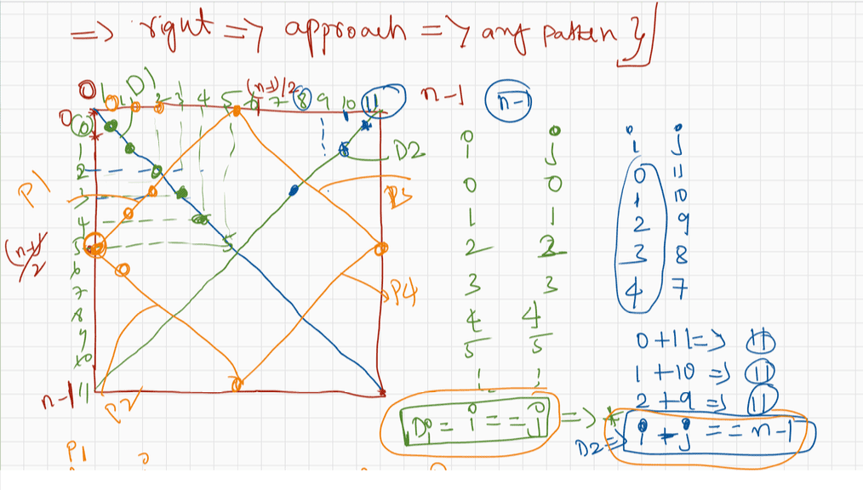
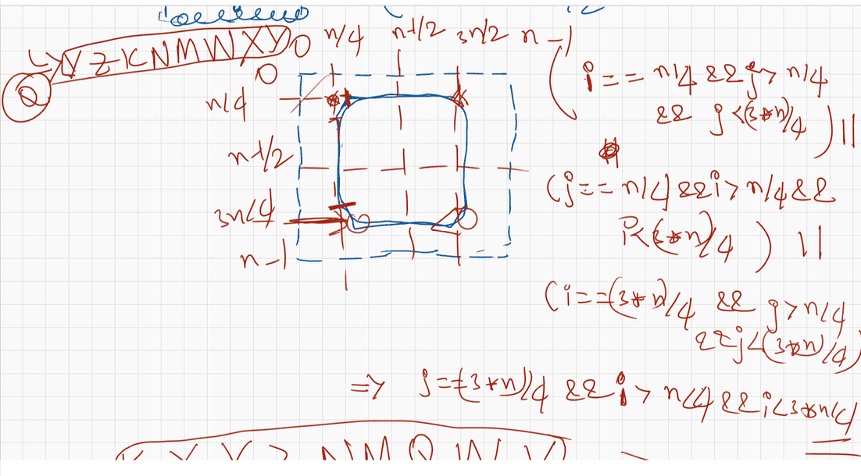
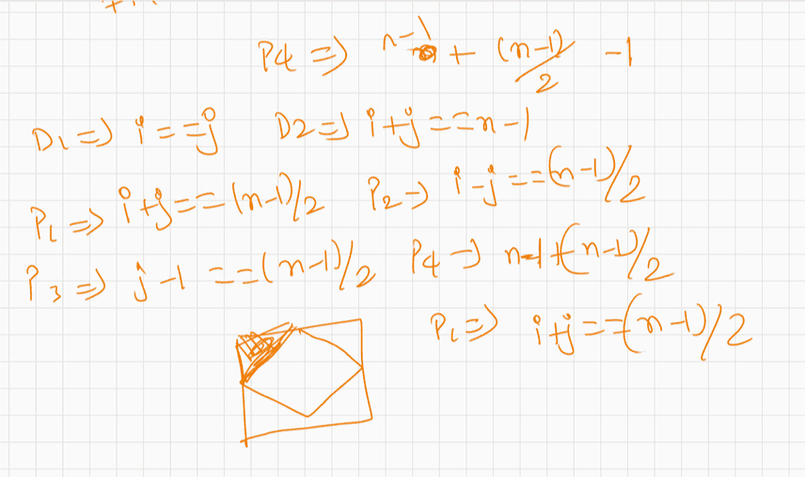

016 Classes , Objects, JVM data areas

Today's topic of discussion
-----------------------------------
Introduction to oops(classes and objects)
Types of variables
Division - 1
a. primtive variable
b. reference variable
Division -2
a. instance variable
b. local variable
c. static variable
JVM Area for execution
a. MethodArea(.class data/static data)
b. Heap Area(instance varaibles/ object data)
c. Stack Area(local varaibles)
d. PC-Register
e. Native method area
OOPs
-------
It is actually theory concept,which is implemented by many programming language
like c++,java,python,...
Any real time problem can be solved if we follow oop's principle.
In OOP's, while solving the problem
1. We need to first mark the Objects.
2. Every Object we mark should have 2 parts
a. HAS-Part/fields/attributes (store the information as
variables)
b. Does-Part/behaviours(represent them as methods)
3. To represent an Object, first we need 2 have a blueprint of an Object.
4. we use "new" keyword/reserve word to create an Object for a
blueprint(class).
5. Every Object should always be in constant interaction
6. Useless Object doesn't exists.
What is Object?
Physical existense of any element we say as Object.
eg: book,Car,Computer,Dog,Student,......
What is Has-Part and What is Does-part of an object represents?
HAS-Part => indicates what it can hold
Does-Part =>indicates what it can do
eg: Student
|=> sid,
name,age,gender,email,address(variables/identifiers)
|=> play,study,drink,sleep(methods)
What is blueprint in java and how to represent it?
In java to represent a blue print we have a reserve word called "class".
Conventions followed by java developers while writing a class is
a. className should be in "PascalConvention".
eg:
BufferedReader,FileReader,InputStream,OutputStream,String,...
b. variables are represented in "camelCase".
eg: regNo,firstName,lastName,length,javaFullStack
c. methods are represented in "camelCase".
eg: toUpper(),toLower(),toString(),nextInt(),.....eg#1.
//Blue print of Student Object
class Student{//Student -> PascalConvention
//HAS-Part ----> camelCaseConvention
int sid;
String name;
int age;
char gender;
String address;
//Does-Part ----> camelCaseConvention
void play(){}
void study(){}
void drink(){}
void sleep(){}
}
To create an object in java we use "new" keyword
Syntax:
ClassName variable=new ClassName();
new -> it is a signal to jvm to create some space for the Object in the heap area.
Tell the className,we inform the classname, JVM create the object and
sends the
"hashCode" to the user.
User should collect the hashCode through "reference variable".
realtime example : BookMyShow
Objects : Person,Ticket,Cinemahall,Chair,3D-glasses,Screen,........
Note : Software means collection of many programs
Programs means set of instructions.
To write instructions we need to have a language.
Types of variables
==============
Division 1 : Based on the type of value represented by a variable all variables are
divided into 2 types.
They are:
1. Primitive variables
2. Reference variables
Primitive variables:
Primitive variables can be used to represent primitive values.
Example: int x=10;
Reference variables:
Reference variables can be used to refer objects.
Example: Student s=new Student();
instance variable
If the variable is declared inside the class, but outside the methods such
variables are called as
"instance variables".or
if the value of the variables changes from object to object then such
variables are called as "instance variables"
eg#1.
Student std1= new Student();//id = 10, name =sachin
Student std2= new Student();//id = 7, name=dhoni
When will the memory for instance varaible be given?
Ans. Only when the object is created JVM will create a memory and by default jvm
will also assign the default value
based on the datatype of the varaible.
eg: int -> 0, float-> 0.0f, boolean -> false,char ->
, String -> null,....
Note: scope of instance variable would be available only when we have reference
pointing to the object,
if the object reference becomes null, then we can't access "instance
varaibles".
Key points about instance varaibles
=============================
Instance variables:
=> If the value of a variable is varied from object to object such type of
variables are called instance variables.
=> For every object a separate copy of instance variables will be created.
=> Instance variables will be created at the time of object creation and destroyed
at the time of object destruction
hence the scope of instance variables is exactly same as scope of objects.
=> Instance variables will be stored on the heap as the part of object.
=> Instance variables should be declared with in the class directly but outside of
any method or block or constructor.
=> Instance variables can be accessed directly from Instance area. But cannot be
accessed directly from static area.
=> But by using object reference we can access instance variables from static area.
eg#1.
public class Test {
boolean b;
public static void main(String[] args) {
Test t=new Test();
System.out.println(t.b);//false
}
}
eg#2
public class Test {
int i=10;//instance variable
public static void main(String[] args) {
System.out.println(i);//CE: instance variable can't be accessed
directly in static context
Test t=new Test();//Object created i = 10 is stored in heap area
System.out.println(t.i);//10
t.methodOne();
}
public void methodOne(){
//inside instance method instace variable can be directly
accessed.System.out.println(i);//10 becoz it is an instance varaible
}
}
local varaibles
------------------
1. Variables which are created inside the method are called local variables and
memory for those variables
will be given in the stackarea.
2. During the execution of the method the memory for local variables will be
given,and after the execution of
the method the memory for variables will be taken out from the stack area.
3. Local varaibles default value will not be given by the JVM, programmer should
give the default value.
4. If the programmer doesn't give default value and if he uses the varaible
inside the method then program would
result in "CE".
Keypoints of Local variables
-------------------------------------
Local variables:
=> Some times to meet temporary requirements of the programmer we can declare
variables inside a method or
block or constructors such type of variables are called local variables or
automatic variables or temporary variables
or stack variables.
=> Local variables will be stored inside stack.
=> The local variables will be created as part of the block execution in which it
is declared and destroyed once
that block execution completes. Hence the scope of the local variables is
exactly same as scope of the block in
which we declared.
=> It is highly recommended to perform initialization for the local variables at
the time of declaration at least
with default values.
eg#1.
public class Test {
public static void main(String[] args) {
int i=0;
for(int j=0;j<3;j++)
{
i=i+j;
}
System.out.println(i);//valid
System.out.println(j);//CE: 'j' variable not declared
}
}
eg#2.
class Test {
public static void main(String[] args) {
try{
int i=Integer.parseInt("ten");
}
catch(NullPointerException e){
System.out.println(i);//CE: 'i' not declared
}
}eg#3.
class Test{
public static void main(String[] args){
int x;
System.out.println("hello");//hello
}
}
eg#4
class Test{
Note: code would be compiled becoz variable x is not used anywhere.
public static void main(String[] args){
int x;
System.out.println(x);//CE: 'x' not initalized
}
}
contact details
hyder : syedhyder@ineruron.ai
nitin : nitin@ineuron.ai
Q>
public class Test{
public static void main(String args[]){
int x=10;
switch(x)
{
case lable so CompileTime Error
}
}
}
A. CompileTimeError
B. hello
C. JVM will create problem at the runtime
D. None of the above
answer : A
System.out.println("hello"); //Statement is not a part of
Q>
switch(args){
case label1: stmt-1;
case label2: stmt-2;
default : stmt-n
}
label in switch should be "Compiletime Constants", meaning the value should be
know to compiler otherwise CE>
public class Test{
public static void main(String args[]){
int x= 10;
int y = 20;
switch(x)
{
case 10: System.out.println("hello");
break;
case y:System.out.println("hiee"); //CE: 'y' value is not
CompileTime Constant
break;
}
}
}
A. CompileTimeError
B. hello
C. hiee
D. JVM will create problem at the runtime
E. None of the above
Answer: A
Q>
public class Test{
public static void main(String args[]){
int x= 10;
final int y = 20;//final means compiler will get to know the value andcompiler treats it as "CompileTime Constant".
switch(x)
{
case 10: System.out.println("hello");
break;
case y:System.out.println("hiee");
break;
}
}
}
A. CompileTimeError
B. hello
C. hiee
D. JVM will create problem at the runtime
E. None of the above
Answer: B
Q>
public class Test{
public static void main(String args[]){
int x=10;
switch(x+1)
{
case 10:
case 10+20:
case 10+20+30:
}
}
}
A. CompileTimeError
B. No Output
C. JVM will create problem at the runtime
D. None of the above
Answer: B
Q>
switch(args){
case label1: stmt-1;
case label2: stmt-2;
default : stmt-n
}
label in switch should be "Compiletime Constants", meaning the value should be
know to compiler otherwise CE>
label value should be with in the range of switch argument type otherwise it would
result in "CE".
public class Test{
public static void main(String args[]){
byte x=10;
switch(x)
{
case 10:System.out.println("hello");
break;
case 100: System.out.println("hiee");
break;
case 1000: System.out.println("byee");//CE: possibly loss of
precession from byte to int
break;}
}
}
A. CompileTimeError
B. hello
D. hiee
Answer : A
C. JVM will create problem at the runtime
Q>
switch(args){
case label1: stmt-1;
case label2: stmt-2;
default : stmt-n
}
label in switch should be "Compiletime Constants", meaning the value should be
know to compiler otherwise CE>
label value should be with in the range of switch argument type otherwise it would
result in "CE".
public class Test{
public static void main(String args[]){
byte x=10;
switch(x+1) //byte + int ----> int , so switch(int)
{
case 10:System.out.println("hello");
break;
case 100: System.out.println("hiee");
break;
case 1000: System.out.println("byee");
break;
}
}
}
A. CompileTimeError
B. hello
D. hiee
E. byee
F. no output
Answer : F
C. JVM will create problem at the runtime
Q>
switch(args){
case label1: stmt-1;
case label2: stmt-2;
default : stmt-n
}
label in switch should be "Compiletime Constants", meaning the value should be
know to compiler otherwise CE>
label value should be with in the range of switch argument type otherwise it would
result in "CE".
case lables value can't be duplicated, if we try to do it would result in "CE".
public class Test{
public static void main(String args[]){
int x=97;
switch(x){
case 97:System.out.println("97");break;
case 99:System.out.println("99");
break;
case 'a':System.out.println("100");// int x= 'a'; break;
x = 97
}
}
}
A. 97
B. CompileTimeError
C. JVM will create problem at the runtime
D. 99
E. 100
Answer: B
Q>
What will be the output of compiling and executing the Test class?
public class Test {
public static void main(String[] args) {
int a = 5;
int x = 10;
switch(x) {
case 10:
a *= 2;//a = a*2 = 5*2 = 10, a = 10
case 20:
a *= 3;//a = a*3 , a=10*3 = 30, a = 30
case 30:
a *= 4;// a = a*4, a =30 * 4 =120, a= 120
}
System.out.println(a);//120
}
}
A. 5
B. 10
C. 30
D. 120
E.CompileTimeError
Answer: D

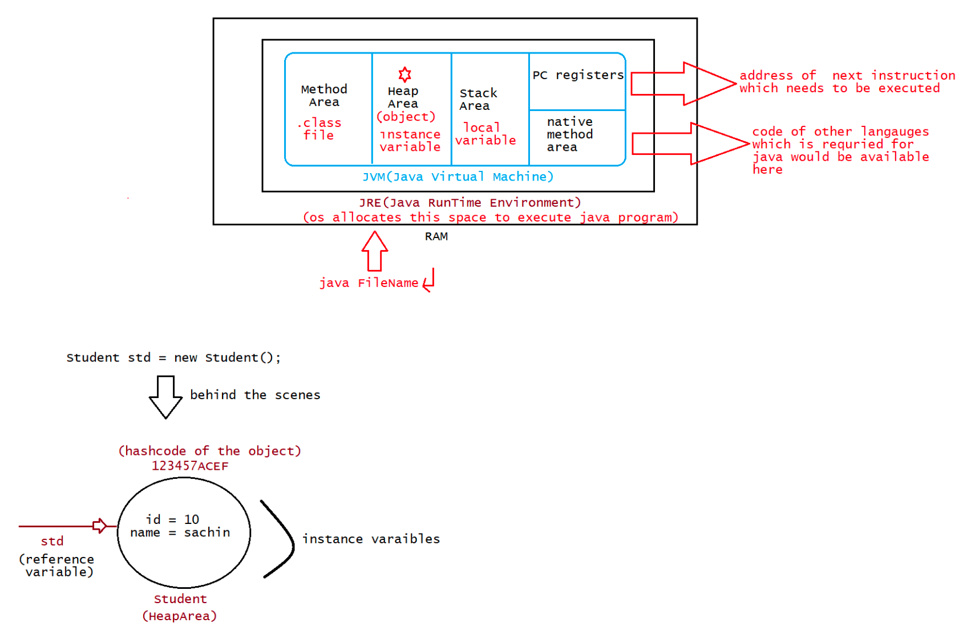

017 Methods in Java and Fundamental of stack and heap area

class Calculator1
{
int a, b, c;

void add()
{
a=10;
b=20;
c=a+b;
System.out.println(c);
}

}

public class LaunchCalc1 {

public static void main(String[] args) {

Calculator1 calc=new Calculator1();

calc.add();

}

}
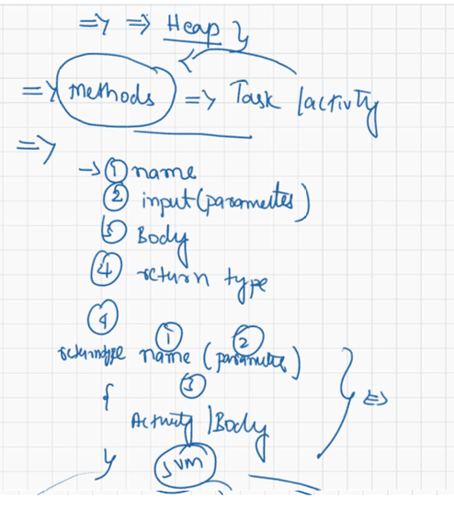

018 Method Overloading and Array Introduction

Q>
Syntax:
while(boolean){
stmt-1;
stmt-2
}
public class ExampleWhile{
public static void main(String args[]){
while(1){//1 is not boolean in java
System.out.println("hello");
}
}
}
A. CompileTime Error
B. Infinite times hello
C. hello
D. some problem by jvm during execution
Answer: A
Q>
public class ExampleWhile{
public static void main(String args[]){
while(true){
System.out.println("hello");
}
}
}
A. CompileTime Error
B. Infinite times hello
C. hello
D. some problem by jvm during execution
Answer: B
Q>
Syntax
while(true)
stmt-1;
; -> it is a valid java statement
public class ExampleWhile{
public static void main(String args[]){
while(true);
}
}
A. CompileTime Error
B. Infinite times hello
C. hello
D. some problem by jvm during execution
E. Infinite loop with no output
Answer: E
Q>
public class ExampleWhile{
public static void main(String args[]){
while(true)
int x =10;//declarative statements are not allowed}
}
A. CompileTime Error
B. some problem by jvm during execution
C. Memory for x will be given 4bytes becoz of type int
D. None of the above
Anser: A
Q>
public class ExampleWhile{
public static void main(String args[]){
while(true){
int x =10;
}
}
}
A. CompileTime Error
B. some problem by jvm during execution
C. Memory for x will be given 4bytes becoz of type int during execution
D. None of the above
Answer: C
Q>
public class ExampleWhile{
public static void main(String args[]){
while(true){
System.out.println("hello");//line-n1
}
System.out.println("hiee");//line-n2
}
}
A. CompileTime Error at line-n1
B. hello infinite times
C. hiee
D. some problem by jvm during the execution
E. CompileTime Error at line-n2
F. None of the above
Answer: E(unreachable code)
Q>
public class ExampleWhile{
public static void main(String args[]){
while(false){
System.out.println("hello");//line-n1
}
System.out.println("hiee");//line-n2
}
}
A. CompileTime Error at line-n1
B. hello
C. hiee
D. some problem by jvm during the execution
E. CompileTime Error at line-n2
F. None of the above
Answer: A(unreachable code)Q>
public class ExampleWhile{
public static void main(String args[]){
int a =10,b=20;
while(a<b){ 10<20 ======> while(true)
System.out.println("hello");//line-n1
}
System.out.println("hiee");//line-n2
}
}
A. CompileTime Error at line-n1
B. hello
C. hiee
D. some problem by jvm during the execution
E. CompileTime Error at line-n2
F. None of the above
Answer: F
Q>
Note: Whenever variables are marked as final, compiler will get to know the value
of those varaibles and it will use the values in the
Expression to get the result.
public class ExampleWhile{
public static void main(String args[]){
final int a =10,b=20;//compiler knows the value of the variables a, b.
while(a<b){// while(10<20) ----> while(true)
System.out.println("hello");//line-n1
}
System.out.println("hiee");//line-n2
}
}
A. CompileTime Error at line-n1
B. hello
C. hiee
D. some problem by jvm during the execution
E. CompileTime Error at line-n2
F. None of the above
Answer: E
Q>
public class ExampleWhile{
public static void main(String args[]){
final int a =10;
while(a<20){// Compiler ====== while(10<20) ---> while(true)
System.out.println("hello");//line-n1
}
System.out.println("hiee");//line-n2
}
}
A. CompileTime Error at line-n1
B. hello
C. hiee
D. some problem by jvm during the execution
E. CompileTime Error at line-n2
F. None of the aboveAnswer: E
Q>
public class ExampleWhile{
public static void main(String args[]){
int a =10;
while(a<20){//JVM======> while(10<20) ====> while(true)
System.out.println("hello");//line-n1
}
System.out.println("hiee");//line-n2
}
}
A. CompileTime Error at line-n1
B. hello
C. hiee
D. some problem by jvm during the execution
E. CompileTime Error at line-n2
F. hello infinite times
G. None of the above
Answer: F
Q>
public class ExampleDoWhile{
public static void main(String args[]){
do
System.out.println("hello");//line-n1
while(true);
}
}
A. CompileTime Error at line-n1
B. hello infinite times
C. some problem by jvm during the execution
D. hello
E. None of the above
Answer: B
Q>
Note: If we are using do while then there should be atleast one statement as the
body otherwise it would result in "CompiletimeError".
public class ExampleDoWhile{
public static void main(String args[]){
do
while(true);
}
}
A. Compile time error
B. some problem by jvm during the execution
C. No output
D. None of the above
Answer: A
Q>
public class ExampleDoWhile{
public static void main(String args[]){do;
while(true);
}
}
A. Compile time error
B. some problem by jvm during the execution
C. No output
D. None of the above
Answer: C
Q>
public class ExampleDoWhile{
public static void main(String args[]){
do
int x =10; //line-n1
while(true);
}
}
A. Compile time error at line-n1
B. some problem by jvm during the execution
C. No output
D. None of the above
Answer: A
Q>
public class ExampleDoWhile{
public static void main(String args[]){
do{
int x =10; //line-n1
}while(true);
}
}
A. Compile time error at line-n1
B. some problem by jvm during the execution
C. No output
D. None of the above
Answer: C
Q>
public class ExampleDoWhile{
public static void main(String args[]){
do while(true)
System.out.println("hello");
while(true);
}
}
A. CompileTime Error
B. hello infinite times
C. some problem by jvm during the execution
D. hello
E. None of the above
Answer: B(refer to the changes made by compiler as shown below)
Compiler will do
---------------------do
while(true)
while(true);
System.out.println("hello");

//Method Overloading
//refers to process of writing more than one method with same name and Diff parameetrs within same class
//earlybinding /compiletime polymorphism
// Compiler resolve the conflict
// a) Number of parameters, b) Data type of parameters c) order of data type of parameters
class Calculator2
{
int add(int a, int b)
{
return a+b;
}

int add(int a, int b, int c)
{
return a+b+c;
}

float add(int a, float b)
{
return a+b;
}

float add(float a, float b)
{
return a+b;
}

float add(int a, float b, float c)
{
return a+b+c;
}

double add(int a, int b, double c)
{
return a+b+c;
}
double add(double a, double b, double c)
{
return a+b+c;
}
double add(int a, double b, int c)
{
return a+b+c;
}
}

public class LaunchMO {

public static void main(String[] args) {

Calculator2 calc=new Calculator2();
int a=10 ,b=30, c=20;
float m=10.5f, n=20.5f, o=30.5f;
double x=15.5, y=25.5, z=35.5;

System.out.println(calc.add(a, b));
System.out.println(calc.add(m, n));
System.out.println(calc.add(a, b, c));
System.out.println(calc.add(x, y,z));
System.out.println(calc.add(a, b, x));

}

}

// return type has no role to play, Its only method name and parameters
class Calculator3
{
int add(int a, int b)
{
return a+b;
}

void add(int a, int b)
{
int res=a+b;
System.out.println(res);
}

float add(int a, float b)
{
return a+b;
}

}
public class LaunchMOCS {

public static void main(String[] args) {
// TODO Auto-generated method stub

Calculator3 cal=new Calculator3();
cal.add(10,20);
}

}

class Calculator5
{

float add(float a, int b)
{
return a+b;
}

float add(int c, float a)
{
return a+c;
}
}
public class LaunchMOCS3 {

public static void main(String[] args) {
// TODO Auto-generated method stub
Calculator5 cal=new Calculator5();
cal.add(10, 20);
}

}

class Display
{
void disp()
{
System.out.println("iNeuron");
}
void disp(String name)
{
System.out.println(name);
}
void disp(int age)
{
System.out.println(age);
}
}
public class LaunchMOG {

public static void main(String[] args) {
// TODO Auto-generated method stub

Display d=new Display();
d.disp();
d.disp(28);
d.disp("Hyder");

}

}

// Can we overload main method in Java?

public class LaunchMOMain {

public static void main(String[] args)
{

System.out.println("Its actual main method ");

}
public static void main(int [] args)
{

System.out.println("accepting int args ");

}
public static void main(double b)
{

System.out.println(" double value");

}

}

// Method overloading with Numeric type promotion
class Calculator4
{

float add(float a, int b)
{
return a+b;
}

float add(float a, float b, int c)
{
return a+b+c;
}
}
public class LaunchMOSC2 {

public static void main(String[] args) {
// TODO Auto-generated method stub

Calculator4 cal=new Calculator4();
System.out.println(cal.add(10, 20));

}

}

019 Array in Java
Topics of discussion for upcoming sessions
a. Generics
b. Collection vs Collections
c. Disucssion on few utility methods
d. Comparable vs Comparator(I)
e. Stream API's
f. Date and Time API
g. enum
h. annotations
i. inner classes
j. fileoperations and io streams
I am still not understanding how you are using 2 methods in a single object.
eg: mapData.getClass().getName(); data.getKey().equals(10)
eg:
String name ="sachin";
String result = name.toUpperCase();
int count=result.length();
System.out.println(count);
vs
String name ="sachin";
System.out.println(name.toUpperCase().length());
Q>Is e.printStack() and sysout(e) same?
Exception object
name of the exception
cause of the exception
line where the exception occured
e.printStackTrace() -> prints the name,cause and line where exception
occured
System.out.println(e) similar to System.out.prinltn(e.toString()) -> name
and cause of exception
Q> Why do we have to always declare System.out.println() inside a method?
Any statement should always be inside a method because of oop's style
coding.
class NameOfTheClass{
//properties(datatypes)
//behaviours(methods)
System.out.println("");
}
Q> Can we implement multithreading with abstract class and interface?
Ans. yes using interface only multithreading is implemented
eg: Runnable(I)
Q>
import java.util.*;
import java.io.*;
public class Properties {
public static void main(String[] args) throws Exception{Properties p1=new Properties();
FileInputStream fin=new FileInputStream("C:\\Users\\VLR\\Desktop\\
db.properties");
p1.load(fin);//------->method load is undefined for type property
}
}
Properties object is not created for java.util.Properties, rather it is created
for userdefined class called "Properties".
solution : change the class name to PropertiesApp then run it will work.
Q>
package Arraylist;
import java.util.*;
public class IteratorArraylist
{
public static void main(String[] args)
{
ArrayList a=new ArrayList();
a.add(100);
a.add(10);
a.add(80);
a.add(50);
Iterator i=a.iterator();
System.out.println("Acccesing data in Forward direction using
Iterator");
while(i.hasNext())
{
System.out.println(i.next());
}
ListIterator l=a.listIterator(a.size());
//cursor is in last position
System.out.println("Accessing data in Backward direction using
ListIterator");
while(l.hasPrevious())
{
System.out.println(l.previous());
}
System.out.println("Accessing data in Forward direction using
ListIterator");
while(l.hasNext())
{
System.out.println(l.next());
}
}
}
Sir, Here why it is necessary to pass size in ListIterator when we want to access
data from last but in LinkedLlist it is not required?
Even in LinkedList, we need to send size() return type otherwise the logic won't
work.
package LinkedList;
import java.util.*;
public class IteratorLinkedList {public static void main(String[] args) {
LinkedList l1=new LinkedList();
l1.add(10);
l1.add(20);
l1.add(30);
l1.add(40);
System.out.println("---------------");
Iterator i=l1.iterator();
while(i.hasNext())
{
System.out.println(i.next());
}
System.out.println("---------------");
ListIterator l=l1.listIterator();
//here cursor is in first positions
while(l.hasNext())
{
System.out.println(l.next());
}
//cursor already in last location
System.out.println("---------------");
while(l.hasPrevious())
{
System.out.println(l.previous());
}
System.out.println("---------------");
Iterator d=l1.descendingIterator();
while(d.hasNext())
{
System.out.println(d.next());
}
}
}
Sir can you please explain higher, ceiling, lower, floor method Sir
higher() -> This method returns the highest value
ceiling(100) -> This method returns the highest value including the
supplied one
lower() -> This method returns the lowest value
floor(100) -> This method returns the lowest value including the supplied
one
A ={100,101,102,103,104,105}
higher(102)-> 103
ceiling(102)-> 102
lower(102) -> 101
floor(102) -> 102
Q>
StringBuffer sb=new StringBuffer("ten");String s=new String("ten");
System.out.println(s.equals(sb)); //false
//if(this == Object) //String == StringBuffer (false)
retur true;
else if ( this instanceof String) return true;
return false;
// String instanceof StringBuffer(false)
Q>
Sir, multithreading pls,
public class Launch {
public static void main(String[] args) {
ThreadA obj = new ThreadA();
Thread t = new Thread(obj);
t.start();
// 2threads(user defined and main thread)
synchronized (obj.total) {
obj.wait();
System.out.println(obj.total);
}
}
}
class ThreadA implements Runnable{
public Integer total=0;
@Override
public void run() {
synchronized (total) {
for(int i=0; i<5; i++) {
total = total + i;
}
total.notify();
}
}
}
1. why total should be made 0 or else it gives NullPointerException
2.Producer synchronize block why total only doesn't work and also with notify it
doesn't work
3. consumer gives exception for obj.total and wait also together? Please correct
the above code and explain...

Q>
public class ExampleDoWhile{
public static void main(String args[]){
do{
System.out.println("hello");//line-n1
}while(true);
System.out.println("hi");//line-n2
}
}
A. CompileTime Error at line-n1
B. hello infinite times
C. hi
D. some problem by jvm during the execution
E. CompileTime Error at line-n2
F. None of the above
Answer: E
Q>
public class ExampleDoWhile{
public static void main(String args[]){
do{
System.out.println("hello");//line-n1
}while(false);
System.out.println("hi");//line-n2
}
}
A. CompileTime Error at line-n1
B. hello
C. hi
D. some problem by jvm during the execution
E. CompileTime Error at line-n2
F. hello
hi
G. None of the above
Answer: F
Q>
public class ExampleDoWhile{
public static void main(String args[]){
int a=10,b=20;
do{
System.out.println("hello");//line-n1
} while(a<b);// JVM ----> while(10<20) ---> while(true)
System.out.println("hi");//line-n2
}
}
A. CompileTime Error at line-n1
B. hello
C. hi
D. some problem by jvm during the execution
E. CompileTime Error at line-n2
F. hello infinite times
g. hi infinite times
h. None of the above
Answer: FQ>
public class ExampleDoWhile{
public static void main(String args[]){
int a=10,b=20;
do{
System.out.println("hello");//line-n1
} while(a>b);//JVM ---> while(10>20) ----> while(false)
System.out.println("hi");//line-n2
}
}
A. CompileTime Error at line-n1
B. hello
hi
C. hi
hello
D. some problem by jvm during the execution
E. CompileTime Error at line-n2
F. hello infinite times
hi
G. None of the above
Answer: B
Q>
public class ExampleDoWhile{
public static void main(String args[]){
final int a=10,b=20;
do{
System.out.println("hello");//line-n1
} while(a<b);//Compiler-----> while(10<20) ---> while(true)
System.out.println("hi");//line-n2
}
}
A. CompileTime Error at line-n1
B. hello
hi
C. hi
hello
D. some problem by jvm during the execution
E. CompileTime Error at line-n2
F. hello infinite times
hi
G. None of the above
Answer: E(concept of unreachable)
Q>
public class ExampleDoWhile{
public static void main(String args[]){
final int a=10,b=20;
do{
System.out.println("hello");//line-n1
} while(a>b);//Compiler ----> while(10>20) ---->
System.out.println("hi");//line-n2
while(false)
}
}
A. CompileTime Error at line-n1
B. hellohi
C. hi
hello
D. some problem by jvm during the execution
E. CompileTime Error at line-n2
F. hello infinite times
hi
G. None of the above
Answer: B
Q>
int i=0,j=0; //line -n1
int i=0,Boolean b=true; //line-n2
int i=0,int j=0; //line -n3
How many statements are valid?
A. line -n1 and line -n3
B. line -n2
C. line-n1, line-n2 and line-n3
D.line -n3
E. line -n1
Answer: E(after , in declartion we need to just specify the variables only )
Q>
Syntax:
}
for(stmt1;stmt2;stmt3){
stmt4;
stmt1 -> can be any statement,but suggested for intitalisation
stmt2 -> compulsorily should be boolean statement only
stm3 -> can be any statement, but suggested for inc/dec on a variable
stm4 -> can be any statement,suggested for repetative logic
public class ExampleFor{
public static void main(String args[]){
int i=0;
for(System.out.println("hello u r sleeping");i<3;i++){
System.out.println("no boss, u only sleeping");
}
}
}
Predict the Output:
A.Compile Time Error
B. Some problem occured by jvm during execution
C. hello u r sleeping
D. no boss, u only sleeping
E.
hello u r sleeping
No boss, u only sleeping
No boss, u only sleeping
No boss, u only sleeping
Answer: E
Q>
public class ExampleFor{
public static void main(String args[]){
int i=0;for(System.out.println("hello");i<3;System.out.println("hi")){
i++;
}
}
}
Predict the Output:
A.Compile Time Error
B. Some problem occured by jvm during execution
C. hello
hi
D.hello
hi
hi
hi
E. hi
hi
hi
hello
F. None of the above
Answer: D
Q>
public class ExampleFor{
public static void main(String args[]){
for(;;){//Compiler---> boolean value will be evaulated as 'true'
System.out.println("hello");
}
}
}
Predict the Output:
A.Compile Time Error
B. Some problem occured by jvm during execution
C. hello
D. infinite times hello
E. None of the above
Answer: D
Q>
public class ExampleFor{
public static void main(String args[]){
for(int i=0;true;i++){
System.out.println("hello");//line-n1
}
System.out.println("hi");//line-n2
}
}
Predict the Output:
A.Compile Time Error at line-n1
B.Compile Time Error at line-n2
C. Some problem occured by jvm during execution
D. hello
hi
D. infinite times hello followed by hi
E. None of the aboveAnswer: B
Q>
public class ExampleFor{
public static void main(String args[]){
for(int i=0;false;i++){
System.out.println("hello");//line-n1
}
System.out.println("hi");//line-n2
}
}
Predict the Output:
A.Compile Time Error at line-n1
B.Compile Time Error at line-n2
C. Some problem occured by jvm during execution
D. hello
hi
D. infinite times hello followed by hi
E. None of the above
Answer: A(remember the concepts of unreachable)
Q>
public class ExampleFor{
public static void main(String args[]){
for(int i=0;;i++){
System.out.println("hello");//line-n1
}
System.out.println("hi");//line-n2
}
}
Predict the Output:
A.Compile Time Error at line-n1
B.Compile Time Error at line-n2
C. Some problem occured by jvm during execution
D. hello
hi
D. infinite times hello
E. None of the above
Answer : B
Q>
public class ExampleFor{
public static void main(String args[]){
int a=10,b=20;
for(int i=0;a<b;i++){//JVM ----> 10<20 ( true)
System.out.println("hello");//line-n1
}
System.out.println("hi");//line-n2
}
}
Predict the Output:
A.Compile Time Error at line-n1
B.Compile Time Error at line-n2
C. Some problem occured by jvm during execution
D. hello
hi
E. infinite times helloF. None of the above
Answer: E
Q>
public class ExampleFor{
public static void main(String args[]){
final int a=10,b=20;
for(int i=0;a<b;i++){//Compiler ----> 10<20 (true)
System.out.println("hello");//line-n1
}
System.out.println("hi");//line-n2
}
}
Predict the Output:
A.Compile Time Error at line-n1
B.Compile Time Error at line-n2
C. Some problem occured by jvm during execution
D. hello
hi
E. infinite times hello
F. None of the above
Answer: B
Note: if a variable is marked as final, then those values are known to compiler so
we say final variables
as "CompiletimeConstants".
if a variable is marked as final, then the value for those variables
should never be changed in the program, if we try
to change it would result in "CompileTimeError".
In java memory for a variable is given by JVM as per its datatype
specification and value also will be assigned.
compiler will not allocate memory for the variables and it will not
initialize the value for the variable.
eg: int a =10;
a++;
System.out.println(a);//11
eg: final int a =10;
a++;//a = a +1;//CE: value can't be re-assigned
System.out.println(a);
import java.util.Scanner;

public class Launch1 {

public static void main(String[] args)
{
System.out.println("Please enter Number");
Scanner scan=new Scanner(System.in);
int a=scan.nextInt();

System.out.println("After taking data from console to program");
System.out.println(a);

}

}

import java.util.*;
public class Launch2
{

public static void main(String[] args)
{
// To store and display marks of 5 students
Scanner scan=new Scanner(System.in);

int[] ar=new int[5];

for(int i=0; i<ar.length;i++)
{
System.out.println("Please Enter marks of student "+ i);
ar[i]=scan.nextInt();
}

System.out.println("The marks of students are as follows");

for(int i=0;i<ar.length;i++)
{
System.out.print(ar[i]+ " ");
}

}

}
import java.util.*;

public class Launch3
{

public static void main(String[] args)
{

Scanner scan=new Scanner(System.in);

int [][] ar=new int[3][4];//array declaration

for(int i=0; i<ar.length;i++)
{
for(int j=0; j<ar[i].length;j++)
{
System.out.println("Enter marks of class "+i +" Student "+j);
ar[i][j]=scan.nextInt();
}

}
System.out.println("The marks of Students are");

for(int i=0; i<ar.length;i++)
{
for(int j=0; j<ar[i].length;j++)
{
System.out.print(ar[i][j] + " ");
}
System.out.println();

}

}

}
import java.util.Scanner;

public class Launch5 {

public static void main(String[] args) {

Scanner scan=new Scanner(System.in);

int [][] ar=new int[3][];//array declaration
ar[0]=new int[3];
ar[1]=new int[4];
ar[2]=new int[2];

for(int i=0; i<ar.length;i++)
{
for(int j=0; j<ar[i].length;j++)
{
System.out.println("Enter marks of class "+i +" Student "+j);
ar[i][j]=scan.nextInt();
}

}
System.out.println("The marks of Students are");

for(int i=0; i<ar.length;i++)
{
for(int j=0; j<ar[i].length;j++)
{
System.out.print(ar[i][j] + " ");
}
System.out.println();

}

}

}
import java.util.Scanner;

public class Launch6 {

public static void main(String[] args)
{
Scanner scan=new Scanner(System.in);

int [][][] hyder=new int[2][3][3];

for(int i=0;i<hyder.length;i++)
{
for(int j=0; j<hyder[i].length;j++)
{
for(int k=0;k<hyder[i][j].length;k++)
{
System.out.println("Enter marks of College "+ i+ " Class "+ j + " Student "+k);
hyder[i][j][k]=scan.nextInt();
}
}
}
System.out.println("Marks stored are as follows");
for(int i=0;i<hyder.length;i++)
{
for(int j=0; j<hyder[i].length;j++)
{
for(int k=0;k<hyder[i][j].length;k++)
{
System.out.print(hyder[i][j][k] +" ");
}
System.out.println();
}
}

}

}

public class Launch7 {

public static void main(String[] args) {
// TODO Auto-generated method stub

int a[]=new int[3];

a[0]=10;
a[1]=20;
a[2]=30;
//Array in Java are guarded with boundaries
//a[3]=40; lead to ArrayIndexOutOfBoundsException during runtime

System.out.println("statment after array");

}

}

public class Launch8 {

public static void main(String[] args) {
// TODO Auto-generated method stub

char a[]=new char[4];
a[0]='a';
}

}

class Fan
{
int cost;
String brand;
int noOfWings;
}

public class Launch9
{

public static void main(String[] args)
{

Fan[] f= new Fan[3];

f[0]=new Fan();
f[1]=new Fan();
f[2]=new Fan();

f[0].brand="Hyder";
f[0].cost=10000;
}

}

public class Launch10 {

public static void main(String[] args) {
// TODO Auto-generated method stub

int [] a1=new int[] {10,20};

int [] a= {10,20,30,40};

char [] c= {'i','N','B','I'};

int[][] ar= new int[][]{{10,20},{20,30}};

int[][] ar1= {{10,20,30},{20,30}};

int[][][] ar2= {{{10,20},{30,40,50}},{{50,60},{70,80}}};

}

}

public class Launch11 {

public static void main(String[] args) {
// TODO Auto-generated method stub

int a[]= {10,20,30,40};

for(int elem:a)
{
System.out.println(elem);
}

}

}

